

**¿QUÉ ESTUDIA?**

Estrella de mar | Icono GratisConch - free iconEstrella de mar | Icono GratisEstrella de mar | Icono GratisConch - free icon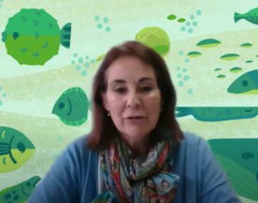

Elena Barcala entrevistada por SCQ+2021 (CC-BY)

ELENA

Coral Basic Straight Flat iconCoral Basic Straight Flat icon

Conch - free iconConch - free iconConch - free iconConch - free iconConch - free iconConch - free iconConch - free iconConch - free icon

**ESPONJAS**

**CABALLITOS DE MAR**

**CETÁCEOS**

**PLÁSTICOS**

**NUTRICIÓN PECES**

Coral Basic Straight Flat iconCoral Basic Straight Flat iconCoral Basic Straight Flat iconCoral Basic Straight Flat iconCoral Basic Straight Flat iconCoral Basic Straight Flat iconCoral Basic Straight Flat iconCoral Basic Straight Flat iconCoral Basic Straight Flat iconCoral Basic Straight Flat iconCoral Basic Straight Flat iconCoral Basic Straight Flat iconCoral Basic Straight Flat icon

Iconos de Flaticon.es



**¿QUÉ ESTUDIA?**

Coral Basic Straight Flat iconCoral Basic Straight Flat iconCoral Basic Straight Flat iconCoral Basic Straight Flat iconCoral Basic Straight Flat iconCoral Basic Straight Flat iconCoral Basic Straight Flat iconCoral Basic Straight Flat iconCoral Basic Straight Flat iconCoral Basic Straight Flat iconCoral Basic Straight Flat iconCoral Basic Straight Flat iconCoral Basic Straight Flat iconCoral Basic Straight Flat iconCoral Basic Straight Flat iconCoral Basic Straight Flat icon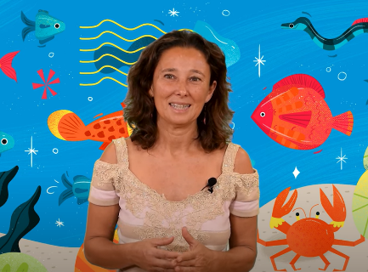Estrella de mar | Icono GratisEstrella de mar | Icono Gratis

Conch - free icon

NATACHA

Estrella de mar | Icono Gratis

Natacha Aguilar Proyecto "Chicas con Cienci@ULL" (CC-BY-SA)

Conch - free iconConch - free iconConch - free iconConch - free iconConch - free iconConch - free iconConch - free iconConch - free icon

**ESPONJAS**

**CABALLITOS DE MAR**

**CETÁCEOS**

**PLÁSTICOS**

**NUTRICIÓN PECES**

Iconos de Flaticon.es



**¿QUÉ ESTUDIA?**

Coral Basic Straight Flat iconCoral Basic Straight Flat iconCoral Basic Straight Flat iconCoral Basic Straight Flat iconCoral Basic Straight Flat iconCoral Basic Straight Flat iconCoral Basic Straight Flat iconCoral Basic Straight Flat iconCoral Basic Straight Flat iconCoral Basic Straight Flat iconCoral Basic Straight Flat iconCoral Basic Straight Flat iconCoral Basic Straight Flat iconCoral Basic Straight Flat iconCoral Basic Straight Flat iconCoral Basic Straight Flat icon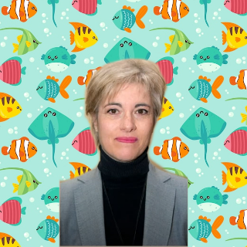Conch - free iconEstrella de mar | Icono GratisEstrella de mar | Icono GratisConch - free icon

MARÍA

Estrella de mar | Icono Gratis

Científicas Recicladas 2021 - María Soledad Izquierdo López

Conch - free iconConch - free iconConch - free iconConch - free iconConch - free iconConch - free iconConch - free iconConch - free icon

**ESPONJAS**

**CABALLITOS DE MAR**

**CETÁCEOS**

**PLÁSTICOS**

**NUTRICIÓN PECES**

Iconos de Flaticon.es



**¿QUÉ ESTUDIA?**

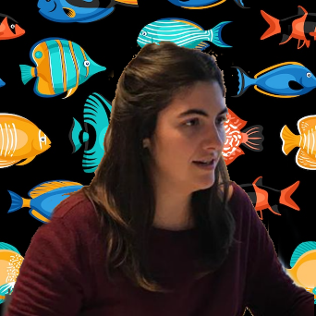

Coral Basic Straight Flat iconCoral Basic Straight Flat iconCoral Basic Straight Flat iconCoral Basic Straight Flat iconCoral Basic Straight Flat iconCoral Basic Straight Flat iconCoral Basic Straight Flat iconCoral Basic Straight Flat iconCoral Basic Straight Flat iconCoral Basic Straight Flat iconCoral Basic Straight Flat iconCoral Basic Straight Flat iconCoral Basic Straight Flat iconCoral Basic Straight Flat iconCoral Basic Straight Flat iconConch - free iconEstrella de mar | Icono GratisConch - free icon

LETICIA

Estrella de mar | Icono Gratis

Oceanográficas: Leticia Serramalera (CC-BY)

Conch - free iconConch - free iconConch - free iconConch - free iconConch - free iconConch - free iconConch - free iconConch - free iconBubbles Generic Flat iconBubbles Generic Flat icon

**ESPONJAS**

**CABALLITOS DE MAR**

**CETÁCEOS**

**PLÁSTICOS**

**NUTRICIÓN PECES**

Iconos de Flaticon.es



**¿QUÉ ESTUDIA?**

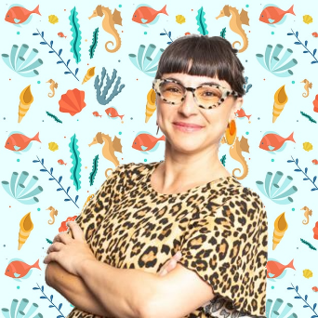

Coral Basic Straight Flat iconCoral Basic Straight Flat iconCoral Basic Straight Flat iconCoral Basic Straight Flat iconCoral Basic Straight Flat iconCoral Basic Straight Flat iconCoral Basic Straight Flat iconCoral Basic Straight Flat iconCoral Basic Straight Flat iconCoral Basic Straight Flat iconCoral Basic Straight Flat iconCoral Basic Straight Flat iconCoral Basic Straight Flat iconCoral Basic Straight Flat iconCoral Basic Straight Flat iconCoral Basic Straight Flat iconConch - free iconEstrella de mar | Icono Gratis

ALICIA

Estrella de mar | Icono Gratis

[www.creaf.cat/](http://www.creaf.cat/) Alicia Pérez

Conch - free iconConch - free iconConch - free iconConch - free iconConch - free iconConch - free iconConch - free iconConch - free icon

**ESPONJAS**

**CABALLITOS DE MAR**

**CETÁCEOS**

**PLÁSTICOS**

**NUTRICIÓN PECES**

Iconos de Flaticon.es