CUENTA Y COLOREA LA PRIMERA LETRA DEL NOMBRE

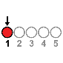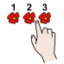

|  |  |  |  |  |
| --- | --- | --- | --- | --- |
|  |  |  |  |  |
|  |  |  |  |  |
|  |  |  |  |  |
|  |  |  |  |  |
|  |  |  |  |  |
|  |  |  |  |  |
|  |  |  |  |  |

1

4

1

4

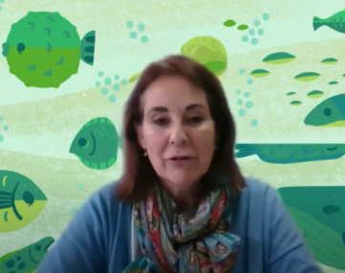

1

4

1

4

3

2

1

4

Elena Barcala entrevistada por SCQ+2021 (CC-BY)

1

4

CUENTA Y COLOREA LA SEGUNDA LETRA DEL NOMBRE

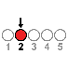

|  |  |  |  |  |
| --- | --- | --- | --- | --- |
|  |  |  |  |  |
|  |  |  |  |  |
|  |  |  |  |  |
|  |  |  |  |  |
|  |  |  |  |  |
|  |  |  |  |  |
|  |  |  |  |  |

4

1

1

4



1

4

1

4

1

4

1

4

Elena Barcala entrevistada por SCQ+2021 (CC-BY)

1

4

CUENTA Y COLOREA LA TERCERA LETRA DEL NOMBRE

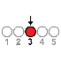

|  |  |  |  |  |
| --- | --- | --- | --- | --- |
|  |  |  |  |  |
|  |  |  |  |  |
|  |  |  |  |  |
|  |  |  |  |  |
|  |  |  |  |  |
|  |  |  |  |  |
|  |  |  |  |  |

1

4

1

4



1

4

1

4

3

2

1

4

Elena Barcala entrevistada por SCQ+2021 (CC-BY)

1

4

CUENTA Y COLOREA LA CUARTA LETRA DEL NOMBRE

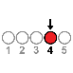

|  |  |  |  |  |
| --- | --- | --- | --- | --- |
|  |  |  |  |  |
|  |  |  |  |  |
|  |  |  |  |  |
|  |  |  |  |  |
|  |  |  |  |  |
|  |  |  |  |  |
|  |  |  |  |  |

2

1

1

1

1

2

1

1



1

2

1

1

2

2

1

1

1

2

1

1

1

1

1

4

1

1

Elena Barcala entrevistada por SCQ+2021 (CC-BY)

CUENTA Y COLOREA LA QUINTA LETRA DEL NOMBRE



|  |  |  |  |  |
| --- | --- | --- | --- | --- |
|  |  |  |  |  |
|  |  |  |  |  |
|  |  |  |  |  |
|  |  |  |  |  |
|  |  |  |  |  |
|  |  |  |  |  |
|  |  |  |  |  |

1

2

2

1

2

1

1



2

4

1

2

2

1

1

1

1

1

1

1

1

4

1

1

Elena Barcala entrevistada por SCQ+2021 (CC-BY)