Analizamos carteles

Reflexiona, busca información y expón tus conclusiones

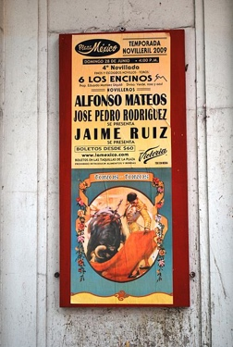  Alejandro Linares García.  Un cartel mexicano para una novillada (2009) | - Historia: ___________________________________________  __________________________________________________  __________________________________________________  - Temática: _________________________________________  __________________________________________________  __________________________________________________  - Soporte: __________________________________________  __________________________________________________  __________________________________________________
  PublicDomainPictures. cartel-vintage-antiguos-guerra  (Pixabay License) | - Historia: ___________________________________________  __________________________________________________  __________________________________________________  - Temática: _________________________________________  __________________________________________________  __________________________________________________  - Soporte: __________________________________________  __________________________________________________  __________________________________________________
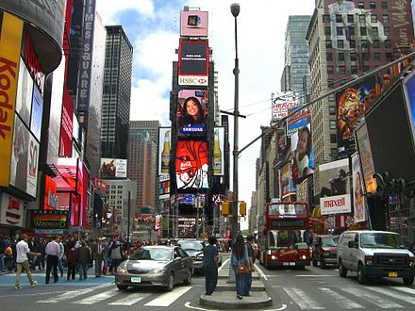  MassimoAbad. Japón-Tokio-Godzilla-Shibuya  (Pixabay License) | - Historia: ___________________________________________  __________________________________________________  __________________________________________________  - Temática: _________________________________________  __________________________________________________  __________________________________________________  - Soporte: __________________________________________  __________________________________________________  __________________________________________________

